Curved Wedge

Definition
# Source: AI Source: Provided by: [Data Path: Persons Table -> ID Column: 1, Name_En Column: Motasem Essam] -> From: [ChatGPT] on [7/25/2026]
A Curved Wedge is a three-dimensional geometric solid characterized by a wedge-like shape with at least one curved surface instead of having only flat polygonal faces.
Its shape may be formed by a curved boundary combined with flat faces, producing a solid that gradually changes in thickness or height.
Unlike a conventional polyhedral wedge, a curved wedge includes one or more curved surfaces.
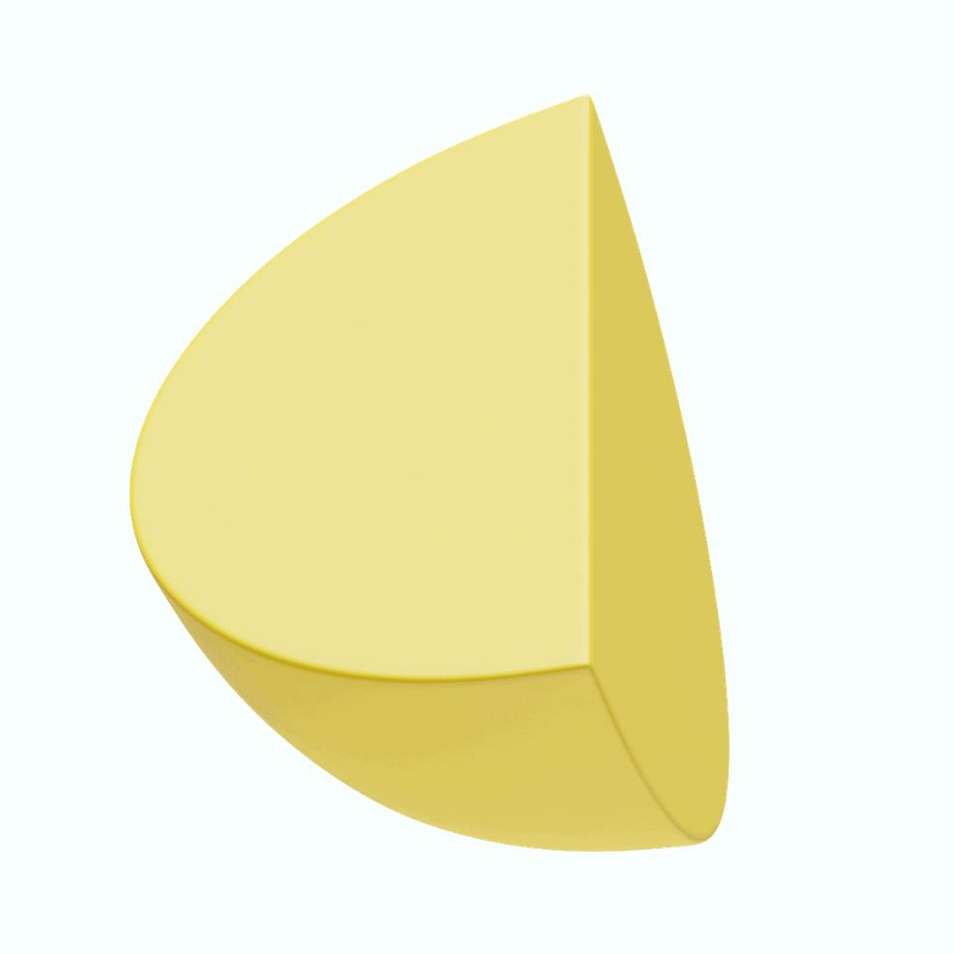
Curved wedge – conceptual geometric illustration.

Solid Geometry – Types of Solids – Wedge – Types of Wedges – Curved Wedge

Definition
# Source: AI Source: Provided by: [Data Path: Persons Table -> ID Column: 1, Name_En Column: Motasem Essam] -> From: [ChatGPT] on [7/25/2026]
A Curved Wedge is a three-dimensional solid wedge that has at least one curved surface. Unlike a conventional polyhedral wedge, which is bounded entirely by flat polygonal faces, a curved wedge is formed by curved boundaries or by cutting a curved solid with one or more planes.
Curved wedges include forms such as conical wedges, cylindrical wedges, and spherical wedges.
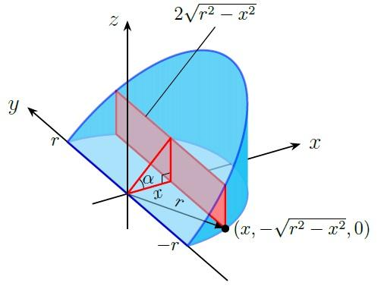
Curved wedge – a conceptual example of a wedge with a curved surface.
Important terminology: “Curved wedge” is a broad descriptive term rather than one uniquely defined polyhedron. Its exact shape, faces, and formulas depend on the curved solid from which it is formed.

Simple Definition
# Source: AI Source: Provided by: [Data Path: Persons Table -> ID Column: 1, Name_En Column: Motasem Essam] -> From: [ChatGPT] on [7/25/2026]
A curved wedge is a three-dimensional wedge-shaped solid with one or more curved surfaces, often produced by cutting a cone, cylinder, or sphere using planes.

Types and Geometric Forms of Curved Wedges

Conical Wedge
# Source: AI Source: Provided by: [Data Path: Persons Table -> ID Column: 1, Name_En Column: Motasem Essam] -> From: [ChatGPT] on [7/25/2026]
A Conical Wedge is a portion of a cone formed by cutting the cone with an inclined plane. The cutting plane is oblique to the circular base and produces a curved solid.
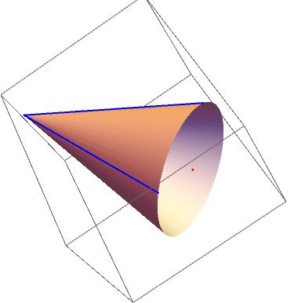

Cylindrical Wedge
# Source: AI Source: Provided by: [Data Path: Persons Table -> ID Column: 1, Name_En Column: Motasem Essam] -> From: [ChatGPT] on [7/25/2026]
A Cylindrical Wedge is a wedge-shaped portion of a cylinder, commonly formed by two intersecting planes. Its boundary includes part of the curved cylindrical surface.
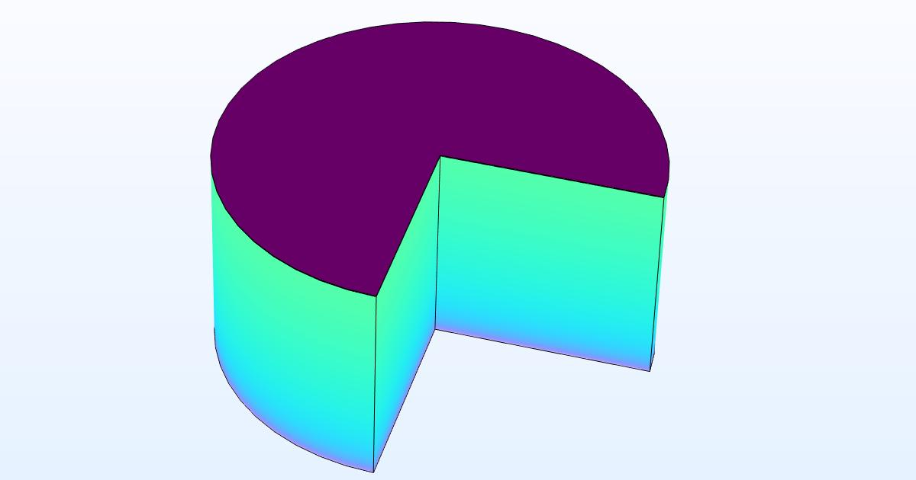

Spherical Wedge
# Source: AI Source: Provided by: [Data Path: Persons Table -> ID Column: 1, Name_En Column: Motasem Essam] -> From: [ChatGPT] on [7/25/2026]
A Spherical Wedge is a portion of a sphere bounded by two planes passing through a diameter and meeting at a central angle. It is formed by revolving a semicircle about its diameter through an angle smaller than a complete revolution.
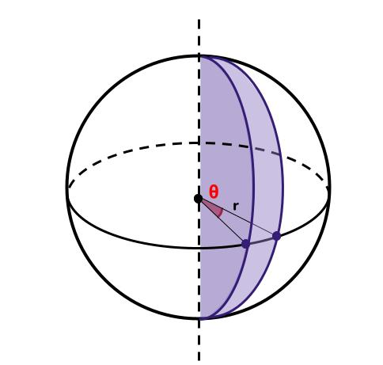

Geometric Structure
# Source: AI Source: Provided by: [Data Path: Persons Table -> ID Column: 1, Name_En Column: Motasem Essam] -> From: [ChatGPT] on [7/25/2026]
The geometric structure of a curved wedge depends on its type.
Its main components may include:
- Curved surface: The outer curved boundary inherited from the original cone, cylinder, or sphere.
- Flat faces: One or more planar surfaces produced by the cutting planes.
- Curved edges: Curved intersections between the curved surface and flat faces.
- Vertices or apexes: May occur in some forms, such as a conical wedge, but are not present in every curved wedge.

Surface Structure
# Source: AI Source: Provided by: [Data Path: Persons Table -> ID Column: 1, Name_En Column: Motasem Essam] -> From: [ChatGPT] on [7/25/2026]
Unlike a conventional polyhedral wedge, a curved wedge does not necessarily have five flat polygonal faces.
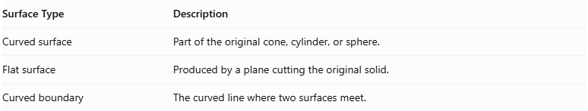
Surface Type | Description
Curved surface | Part of the original cone, cylinder, or sphere.
Flat surface | Produced by a plane cutting the original solid.
Curved boundary | The curved line where two surfaces meet.
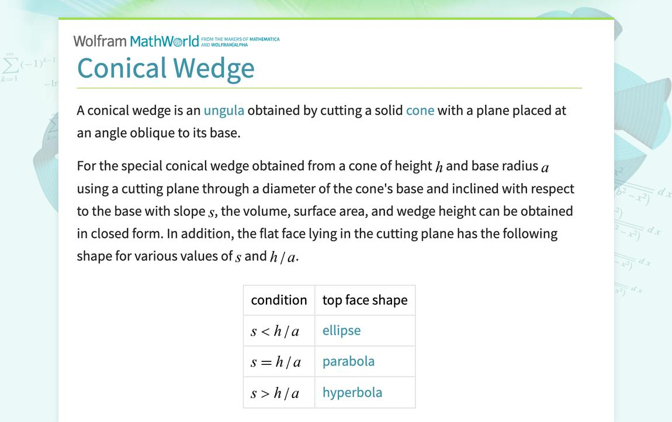

Edge and Vertex Structure
# Source: AI Source: Provided by: [Data Path: Persons Table -> ID Column: 1, Name_En Column: Motasem Essam] -> From: [ChatGPT] on [7/25/2026]
The number and shape of edges and vertices depend on the particular curved wedge.
- Edges: May be curved, straight, or a combination of both.
- Vertices: Some curved wedges have an apex, while others have no vertices.
- Surface intersections: Curved surfaces may meet flat faces along circular, elliptical, or other curved boundaries.

Mathematical Properties
# Source: AI Source: Provided by: [Data Path: Persons Table -> ID Column: 1, Name_En Column: Motasem Essam] -> From: [ChatGPT] on [7/25/2026]
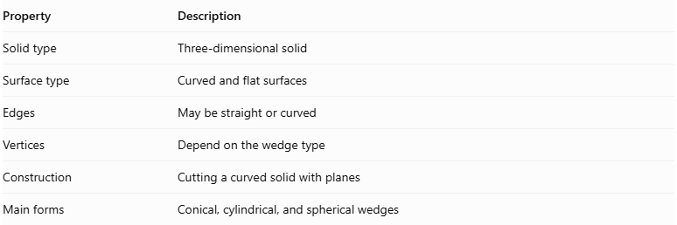
Property | Description
Solid type | Three-dimensional solid
Surface type | Curved and flat surfaces
Edges | May be straight or curved
Vertices | Depend on the wedge type
Construction | Cutting a curved solid with planes
Main forms | Conical, cylindrical, and spherical wedges
A curved wedge does not have one universal number of faces, edges, or vertices.

Surface Area
# Source: AI Source: Provided by: [Data Path: Persons Table -> ID Column: 1, Name_En Column: Motasem Essam] -> From: [ChatGPT] on [7/25/2026]
The total surface area depends on the type of curved wedge.
It generally consists of:
$$\boxed{S=A_{c}+A_{f}}$$
Where:
- $A_{c}$ = total area of the curved surface.
- $A_{f}$ = total area of all flat surfaces.
The exact formula must be selected according to the original solid and the cutting planes.

Volume
# Source: AI Source: Provided by: [Data Path: Persons Table -> ID Column: 1, Name_En Column: Motasem Essam] -> From: [ChatGPT] on [7/25/2026]
The volume of a curved wedge depends on its original curved solid, dimensions, and cutting angles.

Volume of a Spherical Wedge
# Source: AI Source: Provided by: [Data Path: Persons Table -> ID Column: 1, Name_En Column: Motasem Essam] -> From: [ChatGPT] on [7/25/2026]
For a spherical wedge with radius $R$ and central angle $θ$ measured in radians:
$$\boxed{V=\frac{2}{3}R^{3}θ}$$
Where:
- $R$ = radius of the sphere.
- $θ$ = central angle in radians.
If the angle is measured in degrees:
$$\boxed{V=\frac{πR^{3}θ}{270}}$$

Volume of a Conical Wedge
# Source: AI Source: Provided by: [Data Path: Persons Table -> ID Column: 1, Name_En Column: Motasem Essam] -> From: [ChatGPT] on [7/25/2026]
The volume depends on the cone's radius, height, and the inclination of the cutting plane. There is no single formula for every conical wedge configuration.

Volume of a Cylindrical Wedge
# Source: AI Source: Provided by: [Data Path: Persons Table -> ID Column: 1, Name_En Column: Motasem Essam] -> From: [ChatGPT] on [7/25/2026]
The volume can be calculated by integrating the areas of cross-sections perpendicular to a chosen axis:
$$\boxed{V=\int_{a}^{b}{A(x)} dx}$$
Where:
- $A(x)$ = cross-sectional area at position $x$.
- $a,b$ = limits of the solid along the chosen axis.

Symmetry
# Source: AI Source: Provided by: [Data Path: Persons Table -> ID Column: 1, Name_En Column: Motasem Essam] -> From: [ChatGPT] on [7/25/2026]
The symmetry of a curved wedge depends on its original solid and the position of the cutting planes.
- A spherical wedge has rotational symmetry around the axis passing through the sphere's center and the intersection of its bounding planes.
- A conical wedge may have symmetry depending on the cone and cutting plane.
- A cylindrical wedge may have symmetry if its cutting planes and cylindrical boundary are arranged symmetrically.
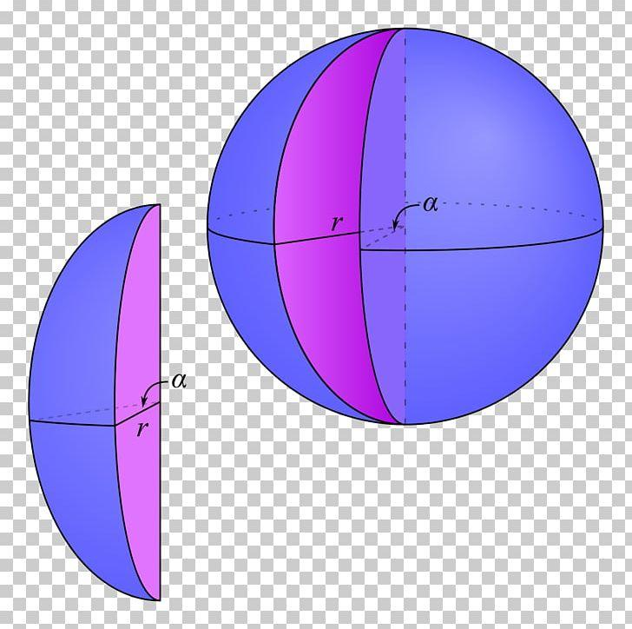

Relationship to Other Solids
# Source: AI Source: Provided by: [Data Path: Persons Table -> ID Column: 1, Name_En Column: Motasem Essam] -> From: [ChatGPT] on [7/25/2026]
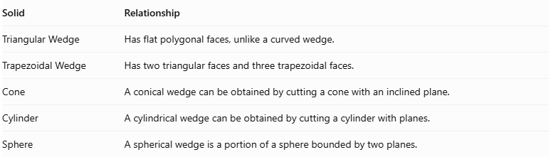
Solid | Relationship
Triangular Wedge | Has flat polygonal faces, unlike a curved wedge.
Trapezoidal Wedge | Has two triangular faces and three trapezoidal faces.
Cone | A conical wedge can be obtained by cutting a cone with an inclined plane.
Cylinder | A cylindrical wedge can be obtained by cutting a cylinder with planes.
Sphere | A spherical wedge is a portion of a sphere bounded by two planes.
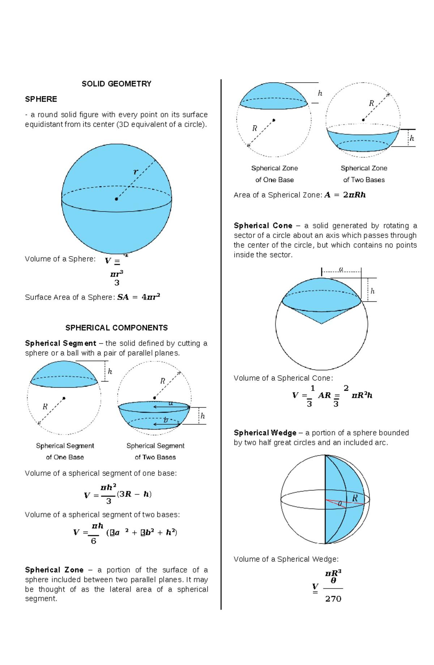

Worked Examples

Example 1: Calculate the Volume of a Spherical Wedge
# Source: AI Source: Provided by: [Data Path: Persons Table -> ID Column: 1, Name_En Column: Motasem Essam] -> From: [ChatGPT] on [7/25/2026]
Given:
- Sphere radius $R=3\text{ cm}$.
- Central angle $θ={60}^{°}$.
Convert the angle into radians:
$$θ=\frac{60π}{180}=\frac{π}{3}$$
Using:
$$V=\frac{2}{3}R^{3}θ$$
Substituting:
$$V=\frac{2}{3}(3)^{3}\left(\frac{π}{3}\right)$$
$$V=6π$$
$$\boxed{V≈18.85{\text{ cm}}^{3}}$$

Example 2: Identify the Curved Wedge Type
# Source: AI Source: Provided by: [Data Path: Persons Table -> ID Column: 1, Name_En Column: Motasem Essam] -> From: [ChatGPT] on [7/25/2026]
A portion of a sphere is bounded by two planes passing through a diameter and forming an angle of ${90}^{°}$.
This solid is a Spherical Wedge.
Its volume is:
$$V=\frac{2}{3}R^{3}\left(\frac{π}{2}\right)$$
$$\boxed{V=\frac{πR^{3}}{3}}$$

Constructing Curved Wedge in Solid Geometry

Geometric Instruments Used
# Source: AI Source: Provided by: [Data Path: Persons Table -> ID Column: 1, Name_En Column: Motasem Essam] -> From: [ChatGPT] on [7/25/2026]

- Ruler: Drawing straight boundaries.
- Compass: Drawing circular and curved outlines.
- Protractor: Measuring central and cutting angles.
- Set square: Constructing perpendicular lines.
- Pencil: Drawing construction lines.
- Eraser: Removing unnecessary construction marks.

Instrument-Based Construction Procedures

A. Constructing the Original Curved Solid
# Source: AI Source: Provided by: [Data Path: Persons Table -> ID Column: 1, Name_En Column: Motasem Essam] -> From: [ChatGPT] on [7/25/2026]
- Choose the required curved solid: cone, cylinder, or sphere.
- Draw its basic outline using a compass and ruler.
- Mark the center, axis, or apex as required.
- Establish the dimensions of the original solid.

B. Constructing the Cutting Plane
# Source: AI Source: Provided by: [Data Path: Persons Table -> ID Column: 1, Name_En Column: Motasem Essam] -> From: [ChatGPT] on [7/25/2026]
- Identify the required cutting position.
- Use a protractor to measure the cutting angle.
- Draw the cutting plane through the curved solid.
- Mark the intersection between the plane and the curved boundary.

C. Forming the Curved Wedge
# Source: AI Source: Provided by: [Data Path: Persons Table -> ID Column: 1, Name_En Column: Motasem Essam] -> From: [ChatGPT] on [7/25/2026]
- Identify the portion of the original solid that forms the wedge.
- Remove the unwanted portion conceptually.
- Draw the remaining curved surface.
- Complete the flat cutting faces.

D. Completing the Curved Wedge
# Source: AI Source: Provided by: [Data Path: Persons Table -> ID Column: 1, Name_En Column: Motasem Essam] -> From: [ChatGPT] on [7/25/2026]
- Darken the visible curved boundaries.
- Darken the visible flat edges.
- Use dashed lines for hidden boundaries when necessary.
- Label the important dimensions and angles.
- Remove unnecessary construction marks.
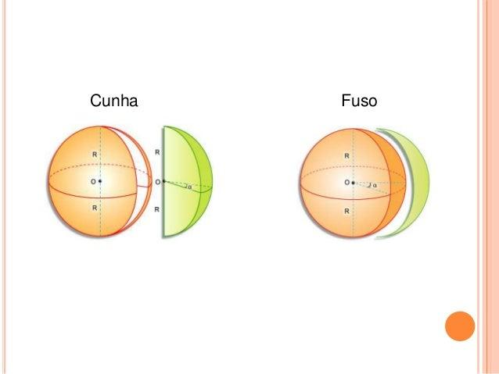

Key Points
# Source: AI Source: Provided by: [Data Path: Persons Table -> ID Column: 1, Name_En Column: Motasem Essam] -> From: [ChatGPT] on [7/25/2026]
- A curved wedge is a three-dimensional wedge-shaped solid with one or more curved surfaces.
- It may be formed by cutting a curved solid using planes.
- Its main forms include conical, cylindrical, and spherical wedges.
- It may contain both curved and flat surfaces.
- Its edges may be straight or curved.
- Its number of vertices depends on its geometric form.
- Its surface area depends on the curved and flat surfaces.
- Its volume depends on the original solid and the cutting arrangement.

Conclusion
# Source: AI Source: Provided by: [Data Path: Persons Table -> ID Column: 1, Name_En Column: Motasem Essam] -> From: [ChatGPT] on [7/25/2026]
A Curved Wedge is a three-dimensional solid characterized by a wedge-like shape and one or more curved surfaces. It can be formed from curved solids such as cones, cylinders, and spheres by using suitable cutting planes.
Its defining characteristic is the combination of curved boundaries and flat surfaces, distinguishing it from conventional polyhedral wedges.

Image and reference sources
# Source: AI Source: Provided by: [Data Path: Persons Table -> ID Column: 1, Name_En Column: Motasem Essam] -> From: [ChatGPT] on [7/25/2026]
- Wedge – Wolfram MathWorld — mathematical classification of wedges and curved wedge forms.
- Conical Wedge – Wolfram MathWorld — conical wedge definition and mathematical properties.
- Spherical Wedge and Spherical Lune – MATHalino — spherical wedge definition and volume formula.
- Applications of Integration – Volume of a Curved Wedge — cylindrical wedge example using cross-sectional integration.

